**Business Case: Target SQL**

**Q1. Import the dataset and do usual exploratory analysis steps like checking the structure & characteristics of the dataset:**

1. Data type of all columns in the "customers" table.

Ans:

Query:

select column_name, data_type

from `first-scaler-415017.business.INFORMATION_SCHEMA.COLUMNS`

where table_name = 'customers'

Screenshot: -

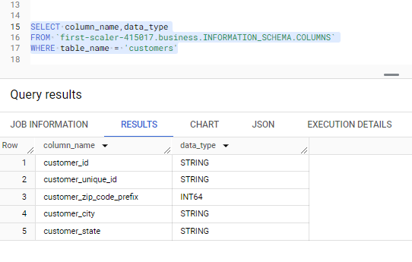

Insights: N/A

Recommendation: N/A

1. Get the time range between which the orders were placed.

Ans:

Query:

select min(order_purchase_timestamp) as min, max(order_purchase_timestamp) as max

from `business.orders`

Screenshot: -

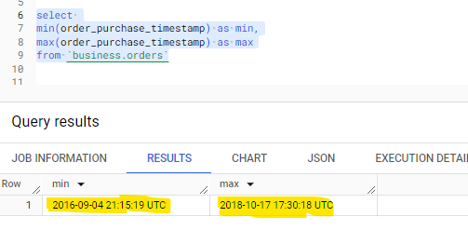

Insights: -

Recommendation: -

1. Count the Cities & States of customers who ordered during the given period.

Ans: -

Query: -

select count(distinct customer_city) as city_count, count(distinct customer_state) as state_count

from `business.customers`

Screenshot: -

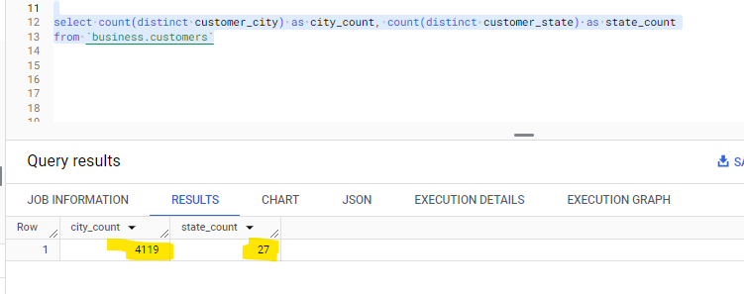

Insights: -

Suggestions: -

**Q2. In-depth Exploration:**



Query:

select year, count(*) as order_count_per_year

from

(select * , extract(year from order_purchase_timestamp) as year

from `business.orders`)

group by year

order by year

Screenshot:

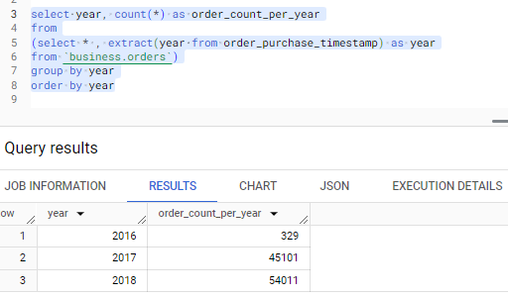

Insights:

Yes, the number of orders were increased over the years

In 2016, we have 329 orders,

In 2017, we have 45,101 orders,

in 2018, we have 54,011 orders.

In 2016 we have only 329 orders because we have data from September 2016 to December 2016. i.e., In 2016 first order in the order table was on 2016-09-04 and last order was on 2016-12-23. Also, if we observe carefully the orders in 2016 are very less, because let us assume in 2017 the total orders are 45000 so on an average 3750 orders were placed every month.

Suggestions:-

2.

3.

Query:

select

different_times, count(different_times) as count_different_times from

(select order_id,order_time,order_purchase_timestamp,

case

when order_time between '00:00:00' and '06:59:59'

then  'Dawn'

when order_time between '07:00:00' and '12:59:59'

then 'Mornings'

when order_time between '13:00:00' and '18:59:59'

then 'Afternoon'

else 'Night'

end as different_times

from(select extract(time from order_purchase_timestamp) as order_time,*

from `business.orders`) tbl1)tbl2

group by different_times

Screenshot:

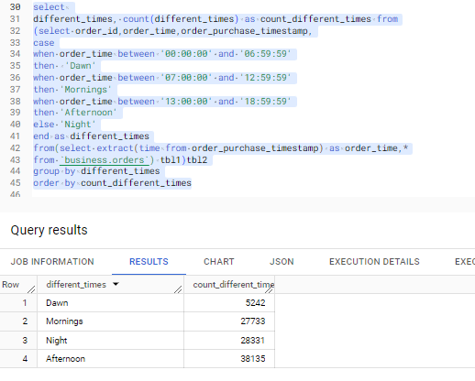

Insights:

Suggestions:

**Q3.** **Evolution of E-commerce orders in the Brazil region:**

1. Get the month-on-month no. of orders placed in each state.

Query:

select geolocation_state, order_month, count(order_id) as no_of_orders from

(select l.geolocation_state, FORMAT_DATE('%B', order_purchase_timestamp) as order_month,order_purchase_timestamp,o.*

from `business.orders` o

join `business.customers` c

on o.customer_id = c.customer_id

join `business.geolocation` l

on c.customer_zip_code_prefix = l.geolocation_zip_code_prefix)

group by geolocation_state, order_month

order by geolocation_state

Screenshot:

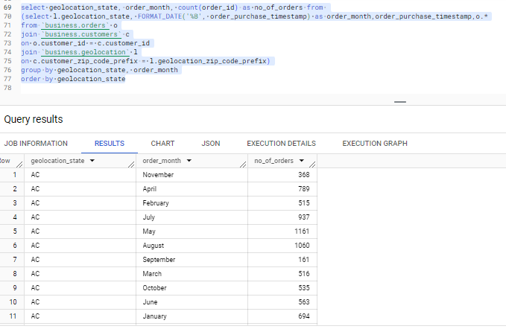

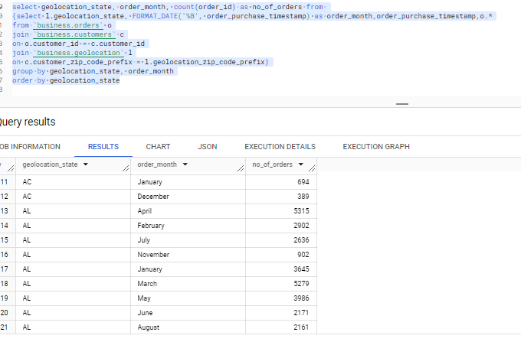

Insights:

Suggestions: